**SQL Lesson 1: SELECT queries 101**

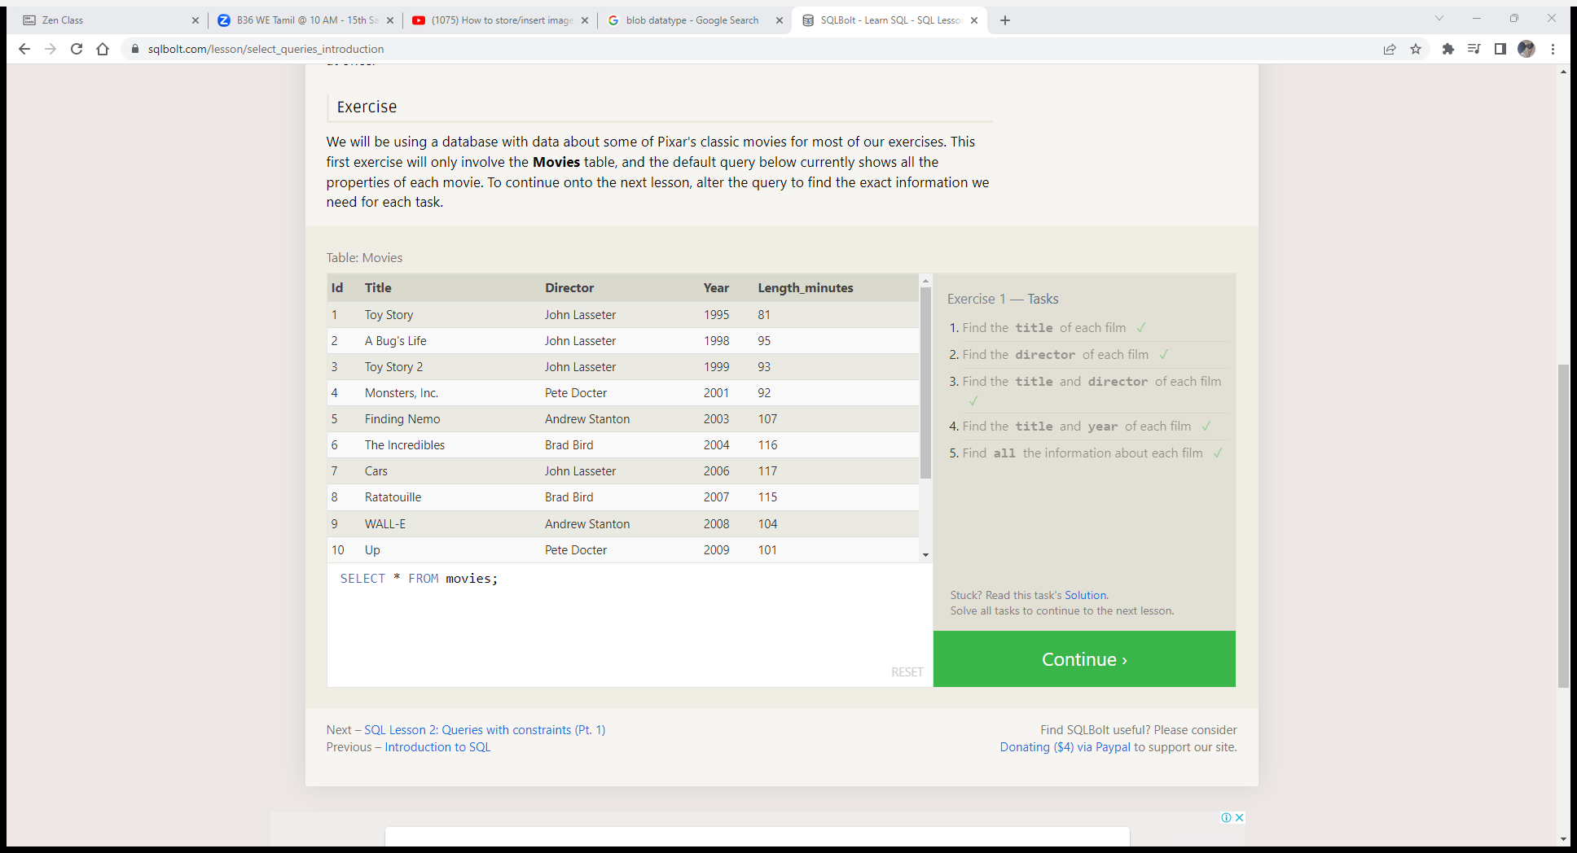

**SQL Lesson 2: Queries with constraints (Pt. 1)**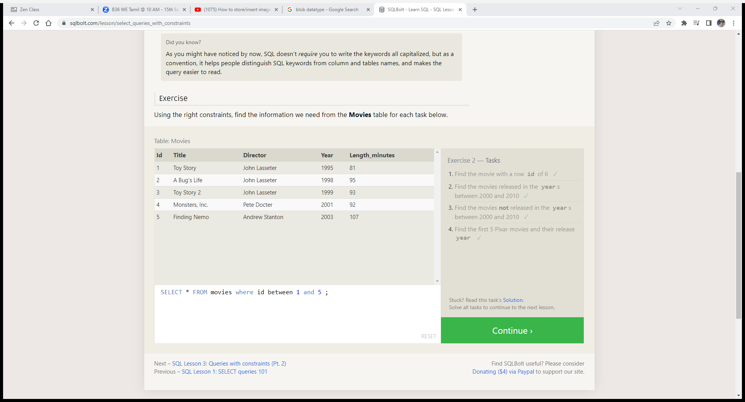

**SQL Lesson 3: Queries with constraints (Pt. 2)**

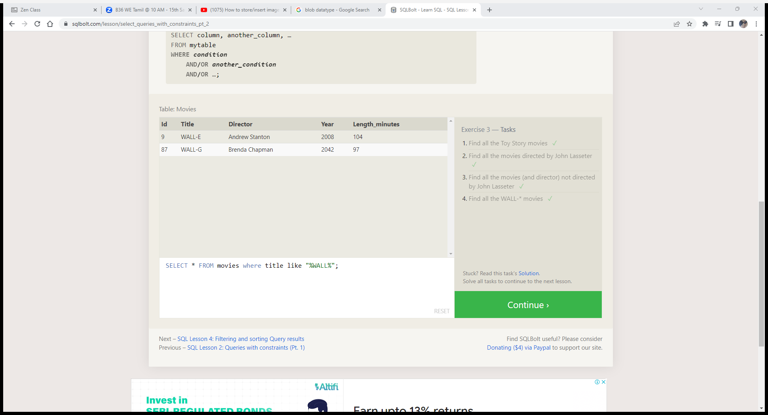

**SQL Lesson 4: Filtering and sorting Query results**

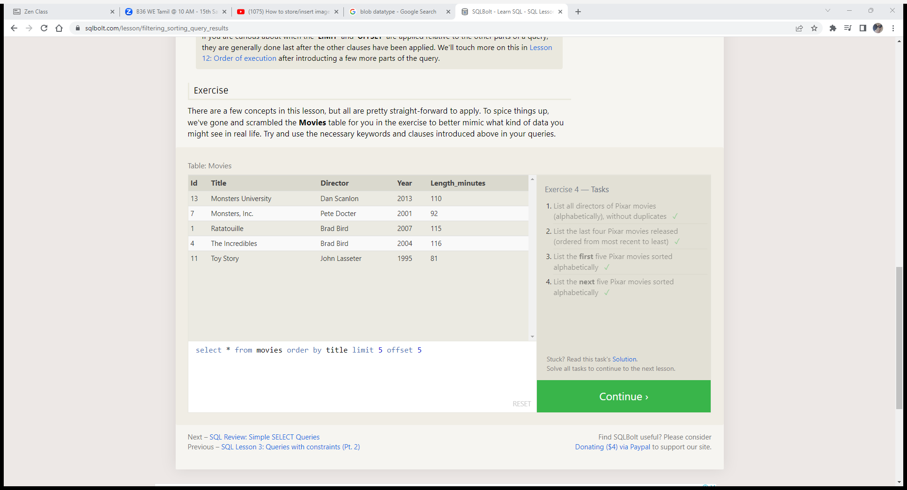

**SQL Review: Simple SELECT Queries**

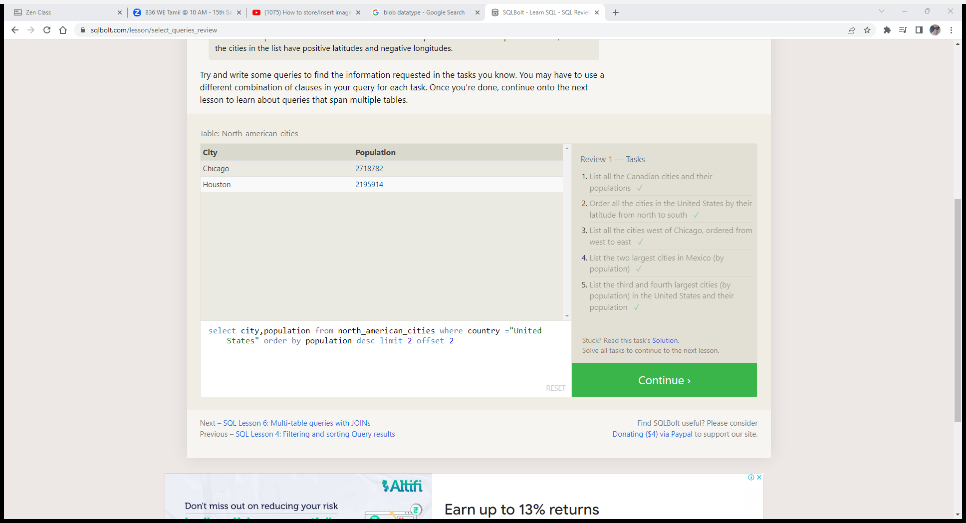

**SQL Lesson 6: Multi-table queries with JOINs**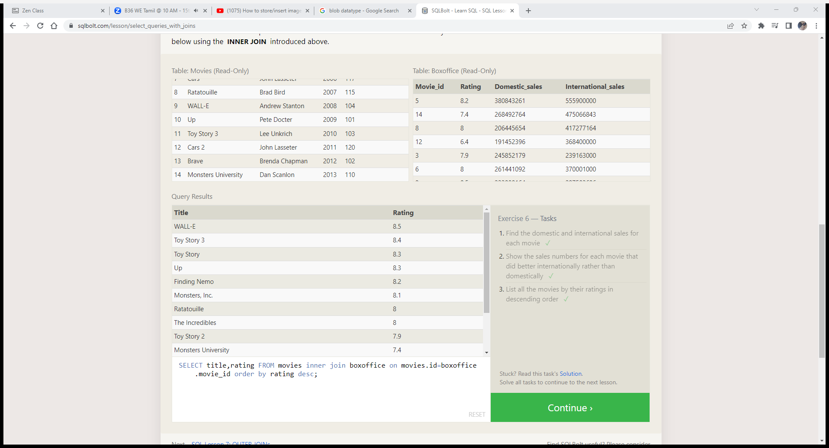

**SQL Lesson 7: OUTER JOINs**

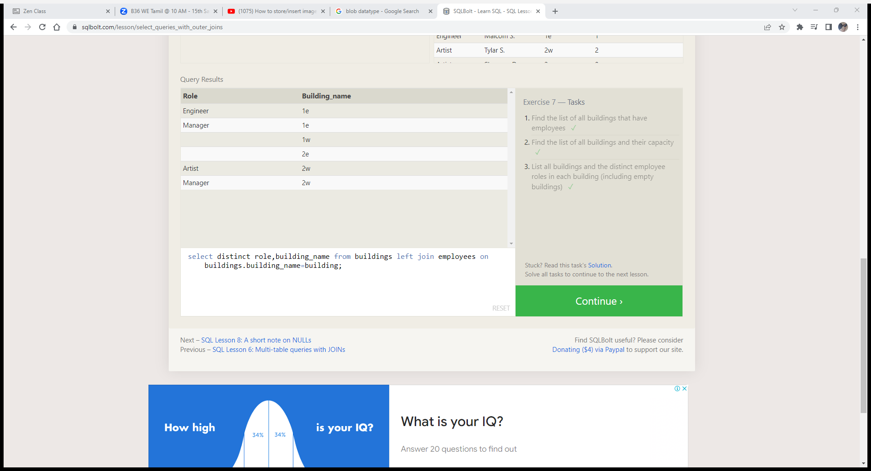

**SQL Lesson 8: A short note on NULLs**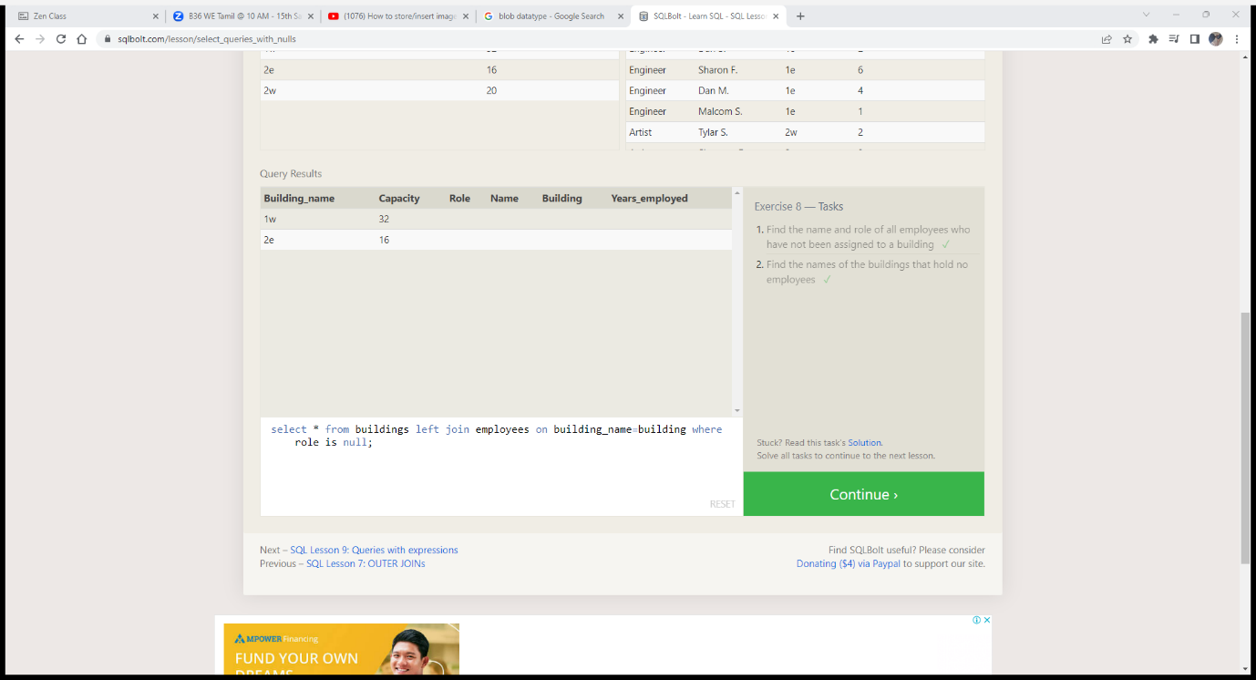

**SQL Lesson 9: Queries with expressions**

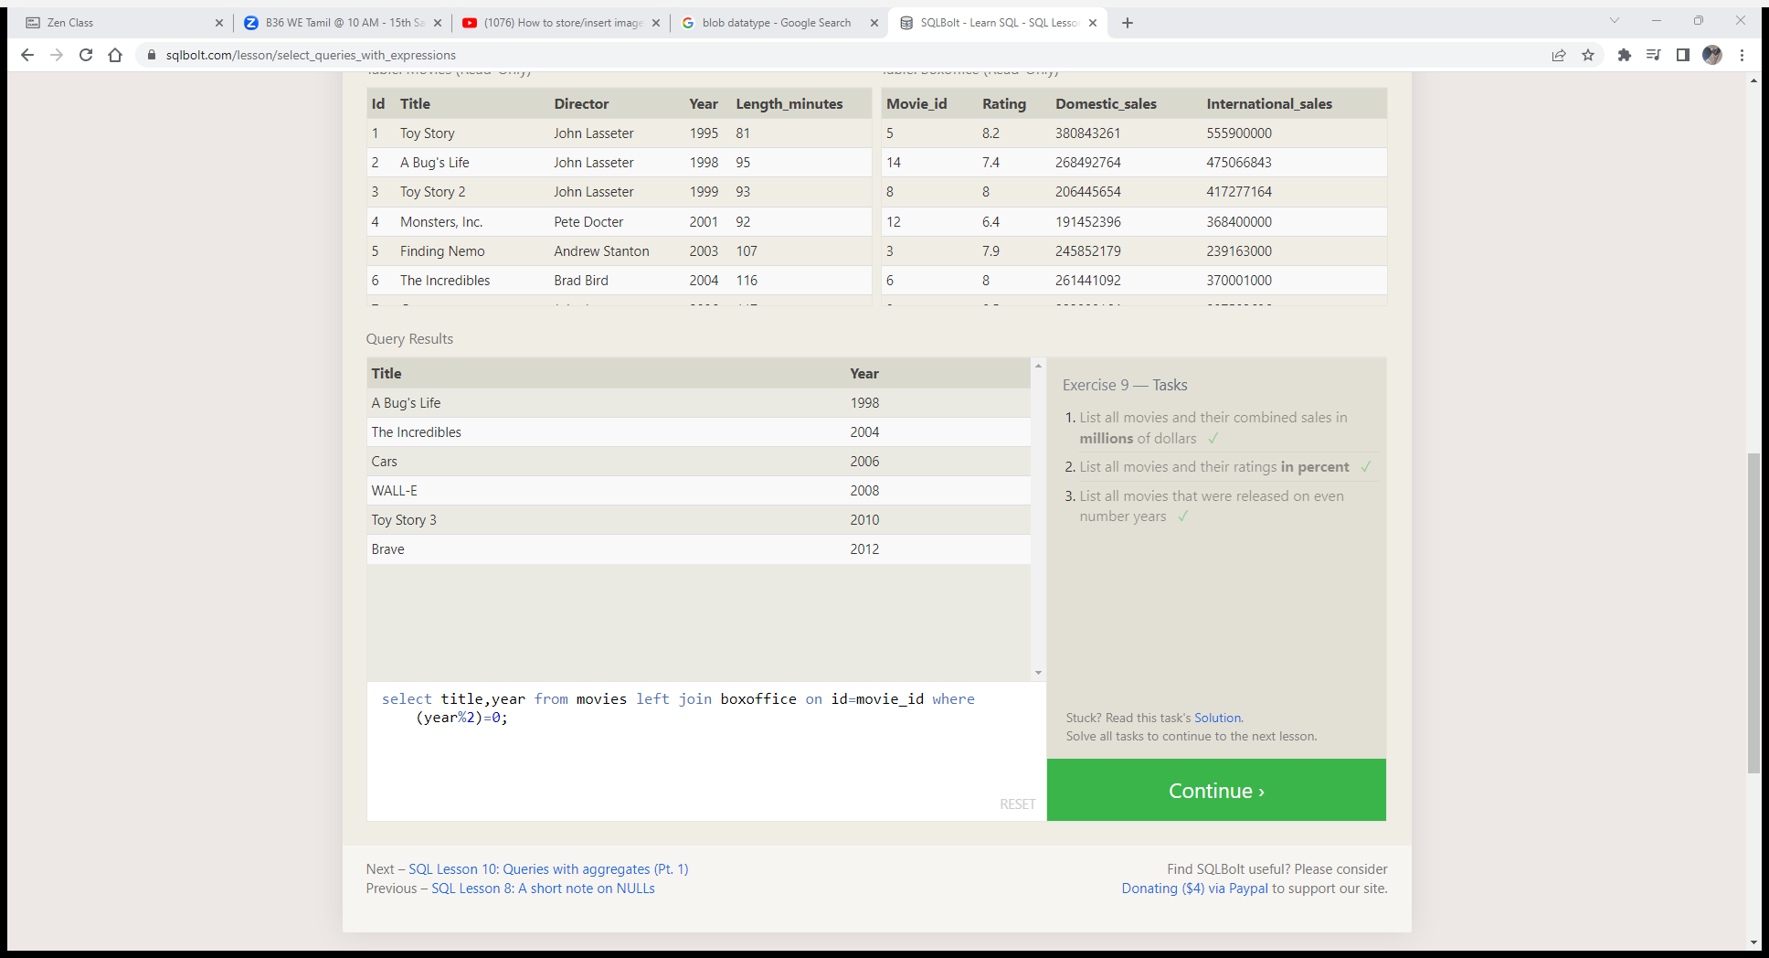

**SQL Lesson 10: Queries with aggregates (Pt. 1)**

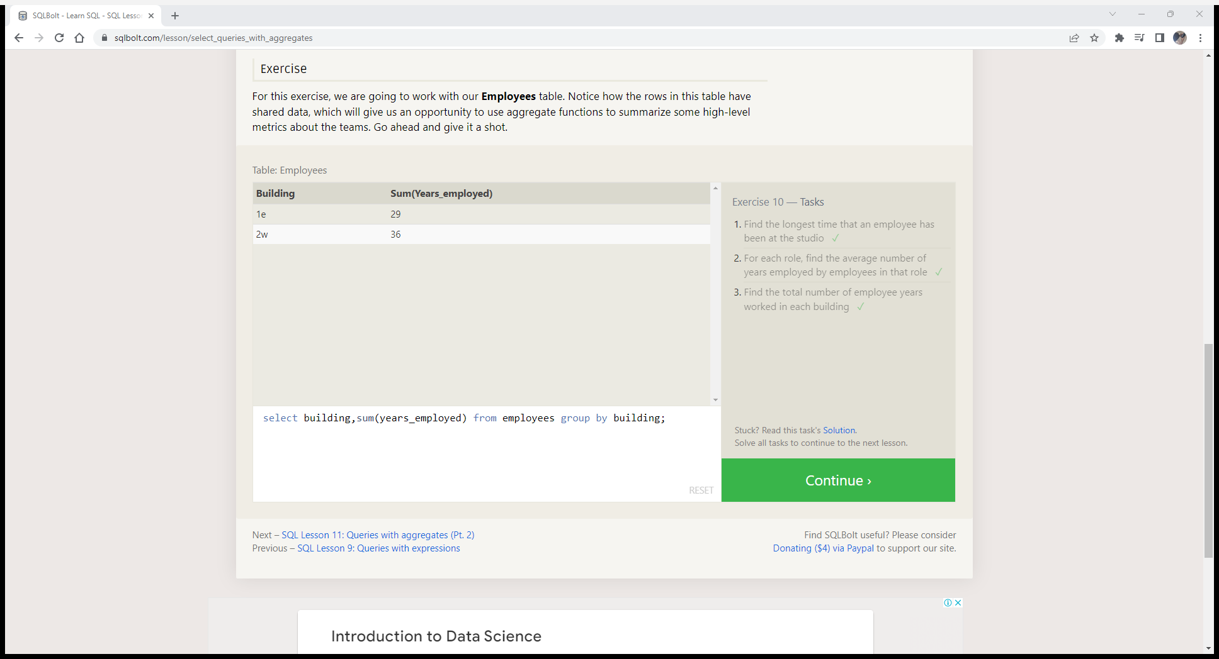

**SQL Lesson 11: Queries with aggregates (Pt. 2)**

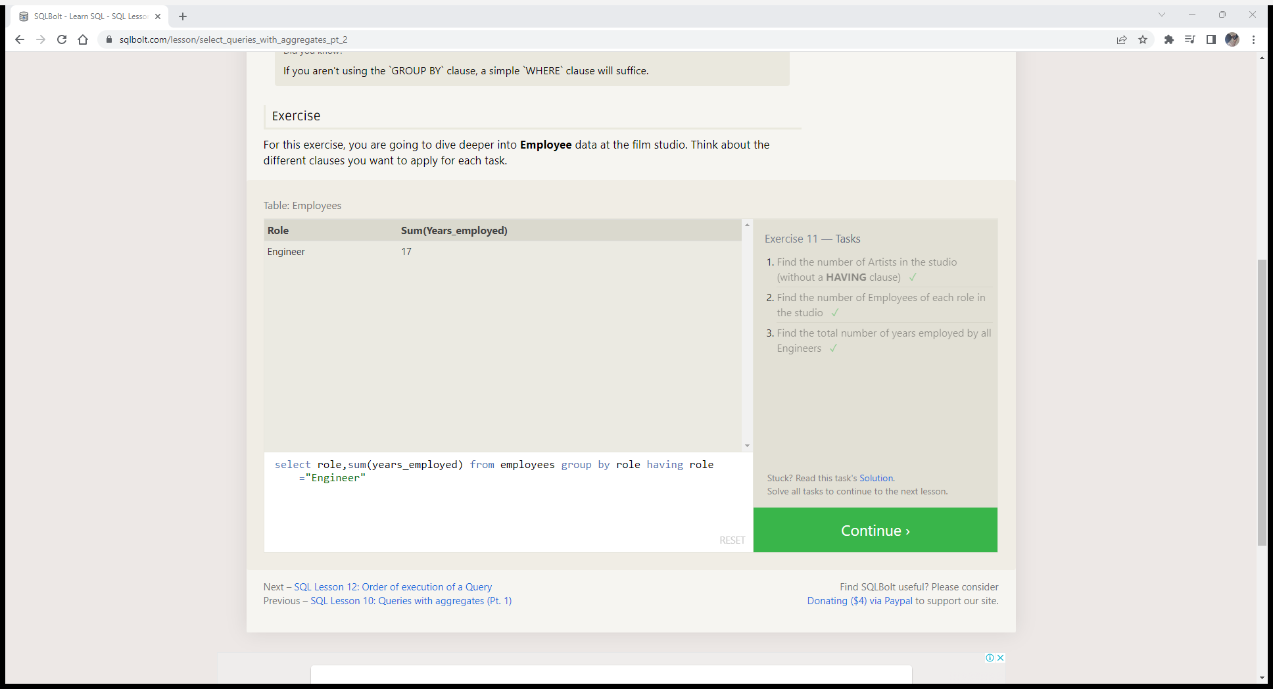

**SQL Lesson 12: Order of execution of a Query**

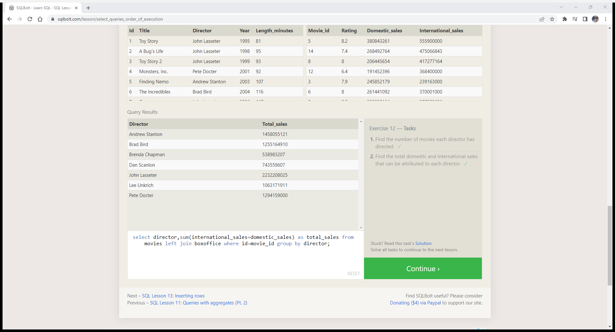

**SQL Lesson 13: Inserting rows**

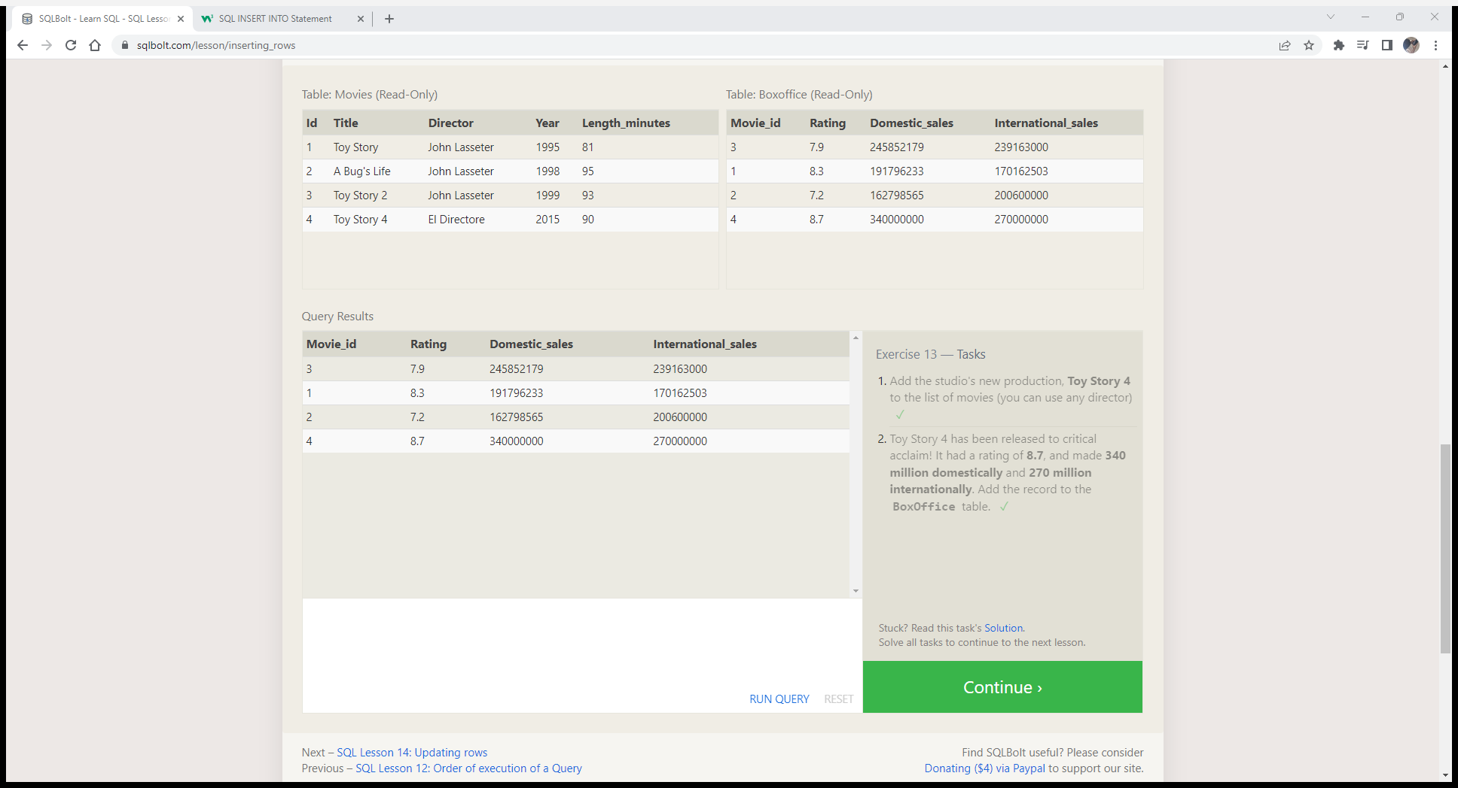

**SQL Lesson 14: Updating rows**

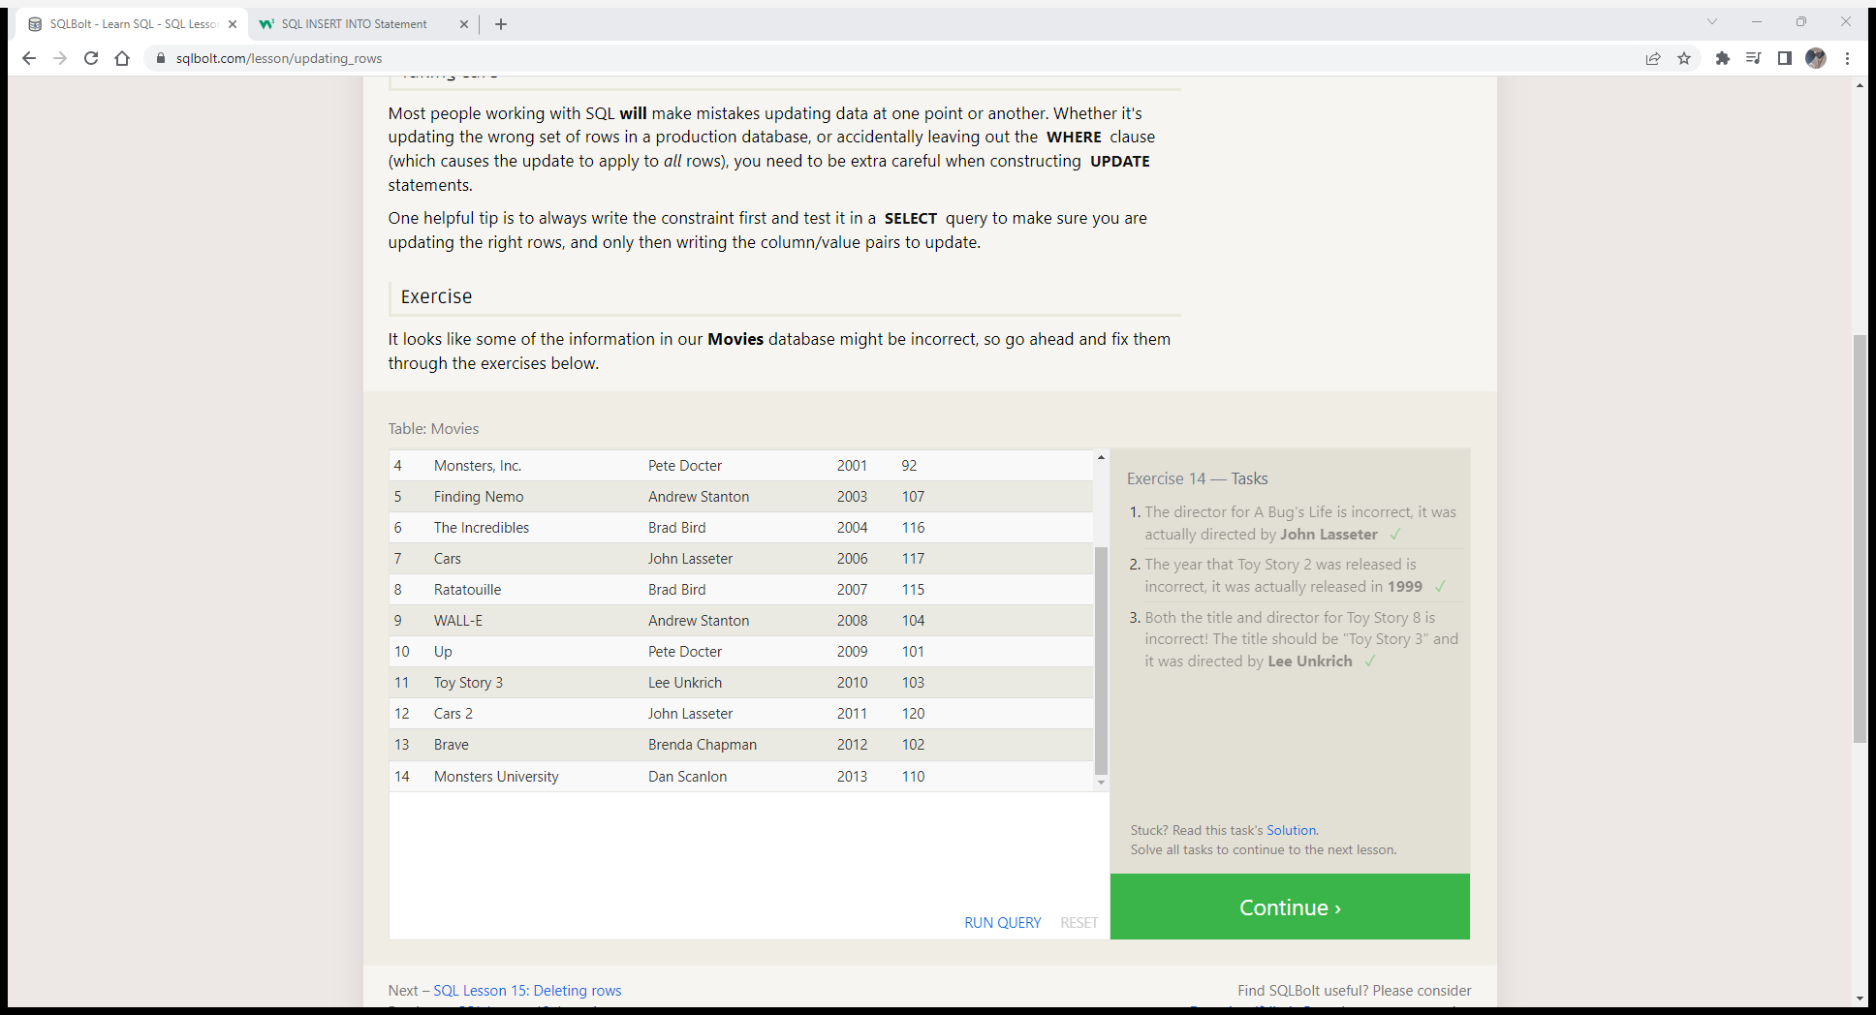

**SQL Lesson 15: Deleting rows**

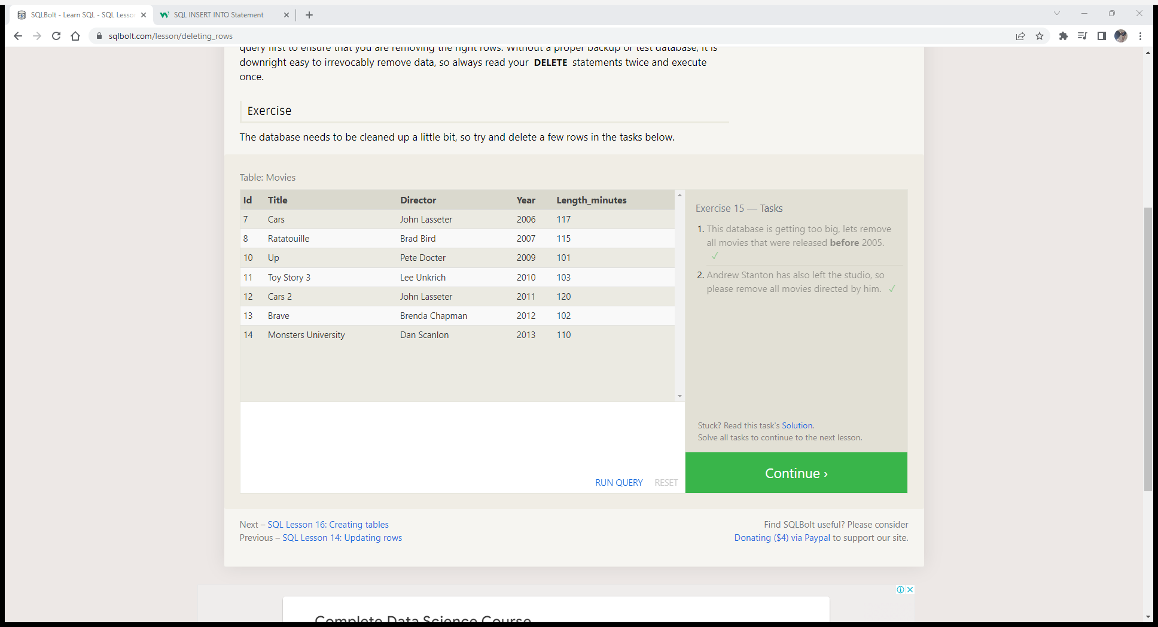

**SQL Lesson 16: Creating tables**

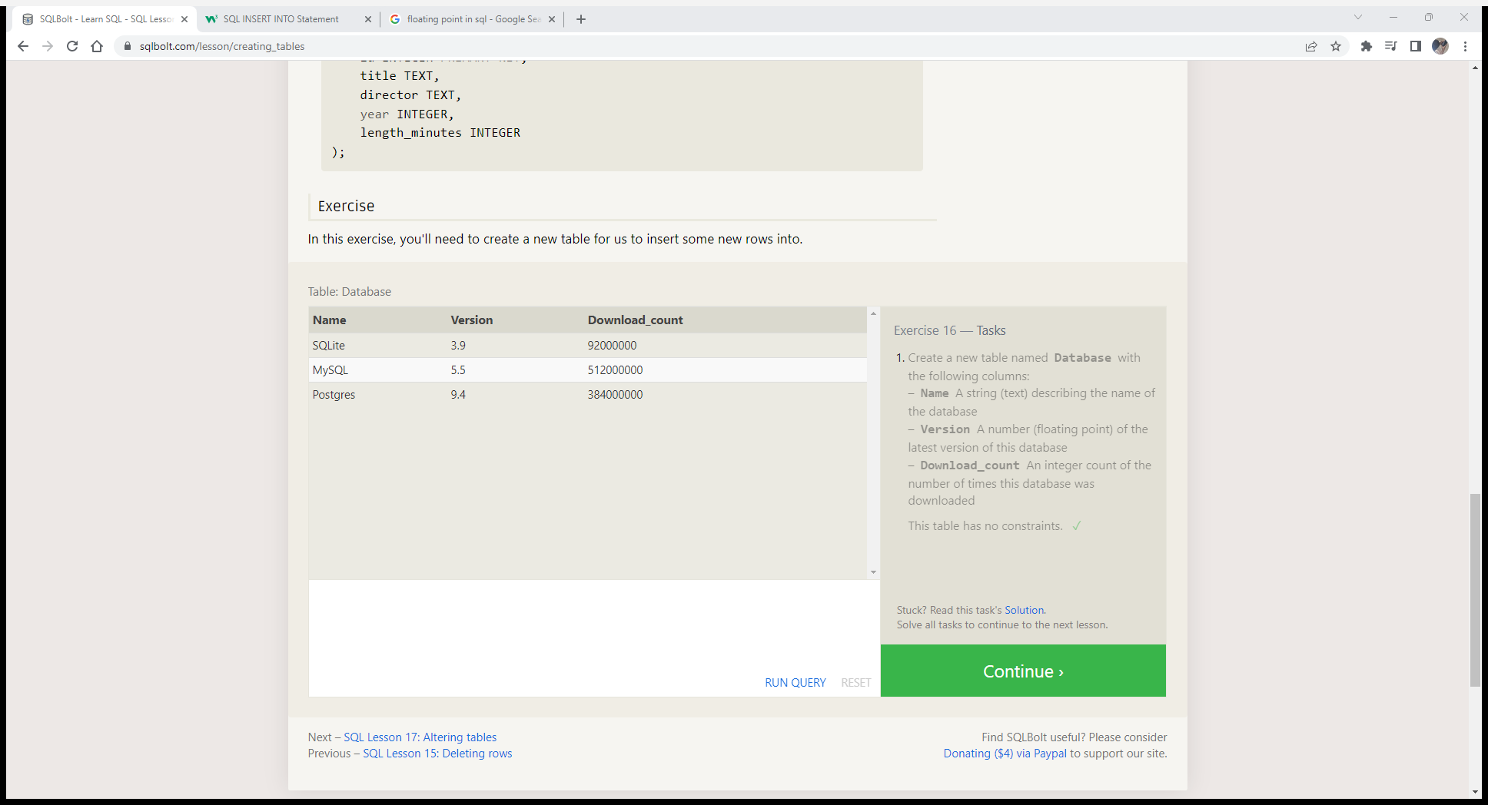

**SQL Lesson 17: Altering tables**

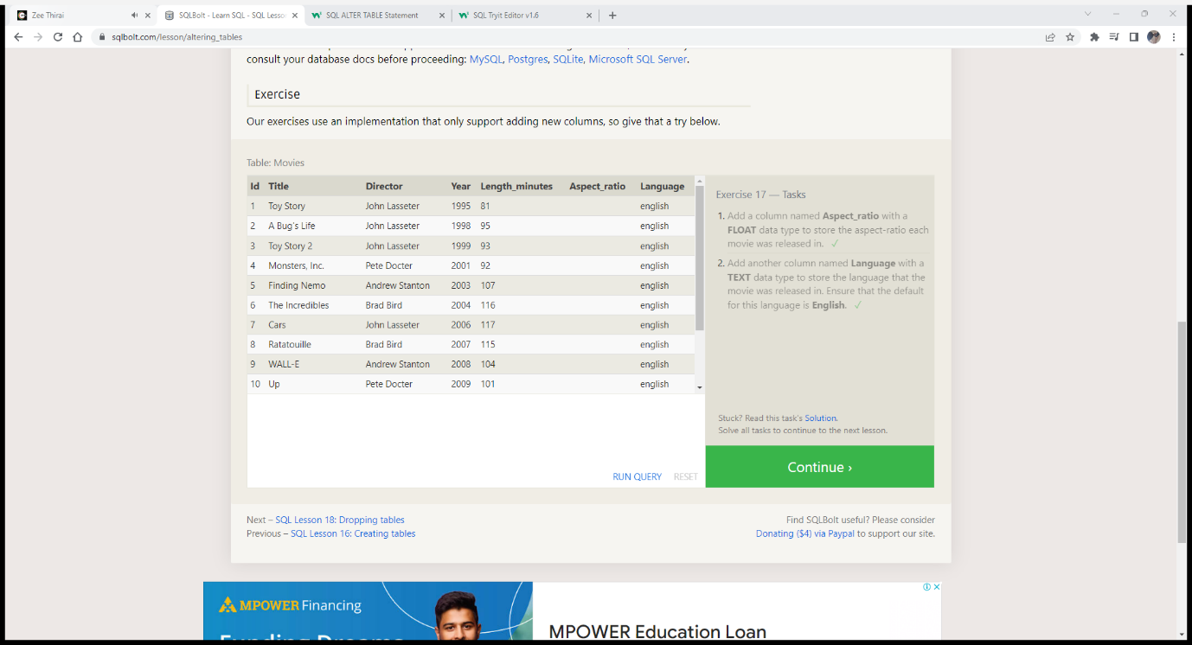

**SQL Lesson 18: Dropping tables**

